**Purdue English Writing 2577  
ISTM Spring Semester 2023 Class date: Mar 01/ Week 3  
Instructor: Mark Custance**

**Model Answer for Task 1 exercise**

**The graph illustrates** the average output of carbon dioxide in metric tonnes for each individual in four European countries over a forty-year period from 1967 to 2007. **Overall**, the United Kingdom and Sweden, which **1._______**showed a high C02 output, saw a decline in emissions throughout the period. Conversely, Italy and Portugal, which started with **2.________**low emissions, **3.___________**big **4.___________**by the end of the period.

**In 1967** the UK had the highest amount of carbon emissions at 11 metric tonnes per person;

**5.______________,** throughout the whole period there was a steady **6.­_________**in C02 output **7._________**at around 9 metric tonnes for each individual. Sweden’s output started at around 9 metric tonnes, rose to a peak of around 11 tonnes in 1977, then saw a sharp decline to **8.___________**half of that by 2007.

**In contrast**, Portugal in 1967 had the lowest output at just over 1 tonne per person. Over the next 40 years, this increased **9.________**, ending at over 5 metric tonnes. Italy **10.__________**a similar pattern, beginning at 4 metric tonnes and ending at nearly 8 tonnes of CO2 for each person by 2007.

|  |
| --- |
| approximately sharply however decline ending witnessed increases initially demonstrated relatively |

**Answering IELTS writing task 1: bar chart**

In this lesson we’re going to learn how to tackle **bar charts** in **IELTS Writing task 1 questions**to get the highest score. To get a *band 9 in IELTS Writing task 1, you should follow this answer structure*:

1. **Introduction**
2. **General overview**
3. **Compare/describe key features**

Let’s look in detail how to apply this structure to an *IELTS bar chart question*.

**IELTS bar chart Question:**

***The bar chart shows the divorce rates in two European countries from 2011 to 2015.   
  
Summarise the information by selecting and reporting the main features, and make comparisons where relevant.***

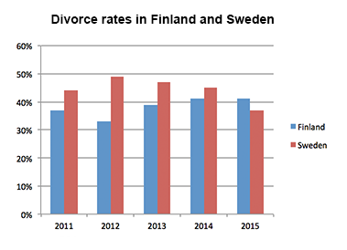

And now let's learn *how to answer IELTS bar chart questions*.

**IELTS bar chart answering strategy:**

**1. Introduction**

You should **start your answer by writing an introduction**. The introduction is 1 or 2 sentences, where you paraphrase the information from your question. You should mention two things in your introduction:

* what your graph shows
* for what period of time

In our example, the introduction can look like this:

***The bar chart provides information about the percentages of divorces in Finland and Sweden between 2011 and 2015.***

See how I ***used synonyms to paraphrase the question***:

**shows → provides information about  
divorce rates → percentages of divorces  
two European countries → Finland and Sweden   
from 2011 to 2015 → between 2011 and 2015.**

**2. General Overview**

**The next part of your answer is a general overview**, where you briefly summarise major trends, changes etc. on your graph. Ideally, **you should mention at least 2 things.**

*To make major trends easier to notice, you can outline Sweden’s bars and Finland’s bars* like this:

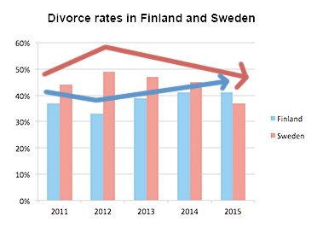

Now it’s obvious that:

* **Sweden** experienced a **downward trend** and **Finland** experienced an **upward trend**
* **both** countries **showed fluctuations**
* **Initially Finland** had a **lower** rate, but in **2015 Finland exceeded Sweden**

Use a word like ***overall/ it is clear that*** to start your general overview. In our case, the overview may look as follows:

***Overall,*** *Sweden experienced a downward trend, while Finland showed an upward trend throughout the period. Both countries’ divorce rates had some fluctuations, and although Finland initially had a lower rate, it exceeded Sweden at the end of the period.*

**3. Compare/describe key features**

**After we’ve written the introduction and general overview, it’s time to give the specific details**. You should describe the specific features about in 2 more paragraphs.

*You can group data in such way*:

* Details about Sweden
* Details about Finland

When you have two countries (or two cities or any other two things depicted on the graph), the simplest way of grouping data - is to describe each country’s trend in a separate paragraph**. BUT you must make comparisons between the countries.**

When giving specific features, you have to ***write numbers/percentages*** and *include the* ***most important details/features.***

**In our case, the specific details may look as follows:**

*Sweden’s divorce rate was about 45% in 2011, being higher than Finland’s rate by* ***approximately*** *8%. Then, it rose to almost fifty percent in 2012. However, the figure showed a gradual decrease to* ***about*** *47% in 2013, and continued to decline steadily to the end of the period, reaching around 45% in 2014 and hitting a low-point of about 37% in 2015.    
The percentage of divorces in Finland was less than 40% in 2011, and it decreased in 2012, when about one third of marriages in Finland ended in a divorce* ***(as opposed to almost a half in Sweden).*** *However, the figure experienced a steady growth during the next two years. It rose to* ***approximately*** *39% in 2013, then increased by* ***around*** *3% in 2014, and remained steady for the next year,* ***exceeding the rate of Sweden.***

**Tips**:

* When analyzing a bar-chart, we cannot always give exact details (due to inaccuracies of the chart), so use words ***around***, ***about*** and ***approximately*** when giving inexact data.

**The full answer + Practice**

It’s the end, we have finally written the answer for IELTS bar chart question. And now, let’s practice: **fill in the gaps in this answer with appropriate words**.

*The****1._______****provides* ***2.­­_________****about the percentages of divorces in Finland and Sweden between 2011 and 2015.* ***3. ­­_________****, Sweden experienced a downward trend, while Finland showed an*

***4. ­­_________****trend throughout the period. Both countries’ divorce rates had some fluctuations. Although Finland initially had a lower rate, it* ***5. ­­_________****Sweden at the end of the period.*

*Sweden’s divorce rate was about 45% in 2011, being higher than Finland’s rate by approximately 8%. Then, it rose to* ***6. ­­_________****fifty percent in 2012. However, the figure showed a gradual decrease to about 47% in 2013, and continued to decline steadily to the end of the period, reaching around 45% in 2014 and hitting a* ***7. ­­_________****of about 37% in 2015.*

*The percentage of divorces in Finland was* ***8. ­­_________****than 40% in 2011, and it decreased in 2012, when about one third of marriages in Finland ended with a divorce (as* ***9. ­­_________****to almost a half in Sweden). However, the figure experienced a steady growth during the next two years. It rose to approximately 39% in 2013, then increased by around 3% in 2014, and remained steady for the next year, outracing the rate of Sweden.*

Here is an IELTS sample bar graph on the topic of British emigration.

This chart is **over time**, so it uses the language of **change as well as language of comparison and contrast**. **Use the model answer above to help you.**

**IELTS Writing Task 1 - Example**

You should spend about 20 minutes on this task*.*

***The chart shows British Emigration to selected destinations between 2004 and 2007.***

***Summarize the information by selecting and reporting the main features and make comparisons where relevant.***

Write at least 150 words.

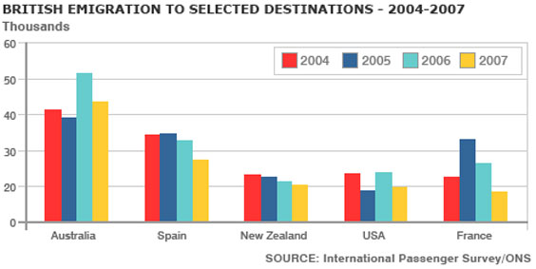

**Remember to write:**

1. **Introduction**
2. **General overview**
3. **Compare/describe key features**

**IELTS Education Vocabulary**

These are useful words and phrases area based around **education vocabulary,** a common topic in IELTS. This vocabulary will help you with all parts of the test if the topic arises.

As with the other vocabulary on these pages, although common word forms are given, not all word forms are here, so remember that once you understand the word you should study it further to make sure you understand exactly how it is used in different contexts.

You will find:

|  |  |
| --- | --- |
| **The word** | The definition |
| An example sentence |

**Education Vocabulary**

|  |  |
| --- | --- |
| **Graduate** | *To complete a first university degree successfully* |
| I **graduated** from the University of Salford in 2009.  My **graduation** ceremony was in 2009. |
| **Curriculum** | *The group of subjects studied in a school, college, etc.* |
| Schools must ensure they have an excellent **curriculum**. |
| **Qualification** | *An official record showing that you have finished a training course or have the necessary skills, etc* |
| Good **qualifications** are really important if you want to get a well-paid job.  I am **qualified** to teach English. |
| **Coursework** | *Regular work done by students as part of a course, but assessed independently of formal exams.* |
| The **coursework** on my degree was really difficult. |
| **Co-educational** | *When male and female students are taught together in the same school or college rather than separately* |
| **Co-educational** schools prepare students for their future better than **single-sex** schools. |
| **Cheat** | *To behave in a dishonest way in order to get what you want* |
| He did really well in his exams but he **cheated**. He copied from a friend.  **Cheating** on exams is not recommended. |
| **Literacy** | *The ability to read and write.* |
| **Literacy** rates have declined considerably in Western countries over the last decade. However, most children are **literate**. |
| **Illiterate** | *Unable to read and write* |
| Many children in the poorest countries are**illiterate.** |
| **Primary (elementary) Education** | *First years of formal education from around age 5 to 11.* |
| A good **primary education** is crucial for a child's development. |
| **Secondary Education** | *Education during the time as a teenager.* |
| I loved it at my **secondary school** as I had so many friends. |
| **Higher (tertiary) Education** | *Non-compulsory education after finishing school, such as university, as well as vocational education and training at colleges.* |
| 60% of children now go into **higher education** after they finish school. |
| **Concentrate** | To direct your attention or your efforts towards a particular activity, subject or problem |
| It is difficult to**concentrate** on my work if there is a lot of noise.  I keep losing **concentration** due to the noise. |

Choose **at least 5 of the words/items** and use them in the essay question below.

**IELTS Free University Education Essay**

The issue of **free university education** is an essay topic that often comes up in the IELTS test.

This essay therefore provides you with some of the key arguments about this topic.

The essay is an **agree / disagree** **essay**, which means you are given **one opinion** and then asked if you agree with it or not.

So, remember to make it clear in your essay which side you are on.

Task 2 Essay

**You should spend about 40 minutes on this task**.

***University education should be free to everyone, regardless of income.   
To what extent do you agree or disagree?***

**Give reasons for your answer and include any relevant examples from your own knowledge or experience. Write at least 250 words**

Of course, you don't have to firmly come down on one side - you could partly agree if there are some aspects of the arguments you agree with but some parts you disagree with.

Remember these steps:

**Introduction:**

A. What are the 2 main things you should do?

1. **Introduce the topic**
2. **Write a thesis/position statement**

**B. Write 2 or 3 sentences**

**Body**: Write **at least 2 body paragraphs**, with one main idea/central topic in each paragraph. Review Lesson 2.

**How to write a conclusion:**

The easiest way to write a conclusion is to **paraphrase the introduction that you have already written**. Start with "In conclusion", and write one or two sentences that summarise your answer.